**Digtial Society**

**A Project Report**

***Submitted by***

## SHUBHAM MEVADA[220SBECE30009] PRATIK PUORHIT[220SBEIT30005] DANGAR JATIN[220SBECE30005] DARHSIL GOHEL[220BEIT30002]

***In fulfillment for the award of the degree***

***Of***

**BACHELOR OF ENGINEERING**

**In COMPUTER ENGINEERING**

**–**

### LDRP INSTITUTE OF TECHNOLOGY AND RESEARCH, GANDHINAGAR

**Kadi Sarva VishwaVidyalaya, Gandhinagar**

**2022- 2023**



## CERTIFICATE

This is to certify that the Project Work entitled **“Digital Society”** has been carried out by **Shubham Mevada [220SBECE30009]**under my guidance in fulfilment of the degree

of Bachelor of Engineering in Computer Engineering (6th Semester) of Kadi Sarva VishwaVidyalaya University, Gandhinagar during the academic year 2022-23.

**Guide:**

**Prof. Riya Gohel Dr. SHIVANGI SURATI**

Internal Guide, H.O.D. CE Dept.,

LDRP-ITR. LDRP-ITR.

**ACKNOWLEDGEMENT**

**SHUBHAM**

**MEVADA [220SBECE30009]**

**INDEX**

|  |  |  |
| --- | --- | --- |
| **SR.NO** | **TOPICS** | **PAGE NO.** |
| 1 | Introduction | 04 |
|  | * Introduction to Current System | 05 |
|  | * Introduction to Your Project | 06 |
| 2 | Objectives | 07 |
| 3 | Problem Definition & Benefits | 08 |
|  | * About existing system | 08 |
|  | * Drawback and Problem with existing system | 09 |
|  | * User Benefits | 09 |
| 4 | System Requirements | 10 |
|  | * Hardware Requirements | 11 |
|  | * Software Requirements | 12 |
| 5 | Front End of System | 13 |
|  | * Introduction to Front-End | 14 |
| 6 | Back End System | 17 |
|  | * Introduction to Back-End | 17 |
| 7 | System analysis and design | 19 |
|  | * System development Lifecycle | 19 |
|  | * Identifies activities of system (Primary) | 21 |
|  | * Feasibility Study | 22 |
|  | * DFD (Data Flow Diagram) | 33 |
|  | * Use Case Diagram | 37 |
|  | * Class Diagram | 38 |
|  | * Sequence Diagram | 39 |
|  | * Data Dictionary | 40 |
| 8 | Screenshots | 41 |
| 9 | Further Enhancement | 44 |
| 10 | Conclusion | 45 |

# Introduction

## Introduction To Current System

Today as We know that the world is become bigger and smarter by the technology and The New innovation so with the growing world we notice some of the loopholes in the system

Currently, The One Android App name as a **MYGATE** is providing the some of the minor security Features like in the **MYGATE** you will known about who is trying to reach you who is coming to meet you

But as We discussed **MYGATE** just providing you a basic information So We

Come Up with New IDEA to make a one system for all the people initiative

We called it **Digital Society** so with this system we can connect the all the member’s chairman and even if Security to the one Portal Where we can communicate and try to make a Safer Place

## Introduction to Your Project

**Project Title:** Digital Society

### Project Definition:

The Main Aim of this project is to established the one secure connection between the Society member, Chairman & Watchman

Our Portal contains so many different options for everyone For Example

A Society Member need anything or wants to communicate with anyone but the Physical Meet is not possible for anything (like Corona Virus) or Maybe that person is out of the area (like USA or anywhere) so That Portal

Helps the everyone to connected and also at a time using this Everyone Will be Updated for the anything

**Why Web App ?**

As We know that the currently all the Society Meeting’s or any Important Details which is Shared Among everyone is Either Share with the Whatsapp or Either Share with the Normal Text messages so It might be Possible that if the notification is very important and if some other messages are popup in the Whatsapp then the Notification messages will go down in the Bar so It might be possible that notification is might be ignored by the user So the WebApp can help you to remember that things with the additional Email Messages or Aleart Pop Ups

So with the Web-App you Can access the Portal Anywhere like in Office in home or anywhere

# Objective

## Objective

The main goal of the proposed work is to improve The Security of Our Society and Make it better for Everyone And Also if anyone ,anywhere need any Help within a Society so it Can might be Possible

**Main Objectives:**

To enable Society to Manage Everything from the one Place and one Portal

### Specific Objectives:

* + To establish possible solutions to improve on The Current Society Security
  + To design and implement Online A portal for the Everyone with Specific

Instruction

* + Easy Network for Everyone

# Problem Definition &

**Benefits**

## Problem Definition & Benefits:

### About existing system:

Currently, most of the Society’s Either Follow their own Application or They Simply Use the MYGATE for the only Entry and Exit Data and Member Details So We are trying to Add Some of the additional Features on it

### Drawback and Problem with existing System:

* + Needed to more Advance
  + Required Manpower
  + Watchman need to do Every Work Theme Self

### Users Benefits:

* + Will Save Time
  + One Step Access to All the things
  + Member can Announce something if they want to
  + No one can miss any Important Updates
  + Create and Established a one network Within A society
  + Automated One Time generated ID password .

# System Requirements

## SYSTEM REQUIREMENTS

A System Requirements Specification (abbreviated SRS when need to be distinct from a Software Requirements Specification SRS) is a structured collection of information that embodies the requirements of a system.

A business analyst, sometimes titled system analyst, is responsible for analyzing the business needs of their clients and stakeholders to help identify business problems and propose solutions. Within the systems development life cycle domain, the BA typically performs a liaison function between the business side of an enterprise and the information technology department or external service providers.

Software requirements specification establishes the basis for an agreement between customers and contractors or suppliers (in market-driven projects, these roles may be played by the marketing and development divisions) on what the software product is to do as well as what it is not expected to do. Software requirements specification permits a rigorous assessment of requirements before design can begin and reduces later redesign. It should also provide a realistic basis for estimating product costs, risks, and schedules.

### Hardware Requirements

* Minimum Hardware
* Like A Normal Pc With Internet Connection
* Minimum 256 MB Ram is Enough

### Software Requirements

* **Operating system** : Windows ,Linux, MAC OS
* **Version** : Python 3.9.10
* **IDE** : Visual Studio Code
* **Back-End** : Python , MySQL
* **Front-End** : HTML , CSS , BootStrap

# Front End of System

## Front-End of System:

### Introduction to Front-End

**HTML:**

HTML is an acronym which stands for **Hyper Text Markup Language** which is used for

creating web pages and web applications. Let's see what is meant by Hypertext Markup

Language, and Web page.

**Hyper Text:** HyperText simply means "Text within Text." A text has a link within it, is a

hypertext. Whenever you click on a link which brings you to a new webpage, you have clicked

on a hypertext. HyperText is a way to link two or more web pages (HTML documents) with each other.

**Markup language:** A markup language is a computer language that is used to apply layout

and formatting conventions to a text document. Markup language makes text more interactive

and dynamic. It can turn text into images, tables, links, etc.

**CSS:**

* CSS stands for Cascading Style Sheets
* CSS describes how HTML elements are to be displayed on screen, paper, or in other media
* CSS saves a lot of work. It can control the layout of multiple web pages all at once
* External stylesheets are stored in CSS files

**BootStrap:**

* Bootstrap is the most popular HTML, CSS and JavaScript framework
* for developing a responsive and mobile friendly website.
* It is absolutely free to download and use.
* It is a front-end framework used for easier and faster web development.
* It includes HTML and CSS based design templates for typography,
* forms, buttons, tables, navigation, modals, image carousels and many others.
* It can also use JavaScript plug-ins.
* It facilitates you to create responsive designs.

# Back End of

**System**

## Back-End of System:

### Introduction to Back-End

**MySQL Database**

**What is MySQL?**

MYSQL is an open-source relational database management system (RDBMS). It is the most popular database system used with PHP. MySQL is developed, distributed, and supported by Oracle Corporation.

* The data in a MySQL database are stored in a table which consists of columns and rows.
* MySQL is a database system that runs on a server.
* MySQL is ideal for both small and large applications.
* MySQL is very fast, reliable, and easy to use database system. It uses standard SQL
* MySQL compiles on a number of platforms.

### Connecting to MySQL database using Python

**There are 3 ways in which we can connect to MySQL from PHP**

* + **Using PYMYSQL Module**
  + **Using MYSQL OBJECT**
  + **Using Python Django Model Method**

# System analysis and Design

## System Analysis and Design:

### System Development Lifecycle:

The System Development Life Cycle framework provides system designers and developers to follow a sequence of activities. It consists of a set of steps or phases in which each phase of the SDLC uses the results of the previous one. A Systems Development Life Cycle (SDLC) is important phases that are essential for developers, such as planning, analysis, designs and implementation and are explained in the section below. A number of system development life cycle (SDLC) models have been created: waterfall, fountain and spiral build and fix, rapid prototyping, incremental, and synchronize and stabilize. The oldest of these, and the best known, is the waterfall model: a sequence of stages in which the output of each stage becomes the input for the next. These stages can be characterized and divided up in different ways, including the following:

**Project planning, feasibility study:** Establishes a high-level view of the intended project and determines its goals.

**System requirements definition:** Refines project goals into defined functions and operation of the intended application. Analysis end-user information needs.

## Identifies activities of system (Primary):

### Open Portal:

The Authorized Chairman ID Password is super user id password so the id password is given in database already

### Add-Member:

The Chairman Can Add the Member using the Form and access that is given to the user

### Member-Login:

Once the Member Registration Is done the member got his/her Permanent User id and Temporary Password. Member Login Using that Id Password

### Member Options:

Once the Member Login to the Portal it shows the Varity of Options like

* Member Details
* Add Family Member
* Family Member Details
* View Notice
* Make Some Important announcement (if Chairman Permits)
* View their Personal Notice like Maintenance

### Raise a Alert:

Along with that A Member Can Raise A Security Alarm That Alert the Security About any Security related Issue

### Generate A work :

Member Can also make her/his Profession Public so within A society Any one can Reach if they Want to

## Feasibility Study:

**Feasibility Study** is an assessment of the practicality of a proposed project or system.

A feasibility study aims to objectively and rationally uncover the strengths and weaknesses of an existing business or proposed venture, opportunities and threats present in the natural environment, the resources required to carry through, and ultimately the prospects for success. In its simplest terms, the two criteria to judge feasibility are cost required and value to be attained.

A well-designed feasibility study should provide a historical background of the business or project, a description of the product or service, accounting statements, details of the operations and management, marketing research and policies, financial data, legal requirements and tax obligations. Generally, feasibility studies precede technical development and project implementation.

A feasibility study evaluates the project's potential for success; therefore, perceived objectivity is an important factor in the credibility of the study for potential investors and lending institutions. It must therefore be conducted with an objective, unbiased approach to provide information upon which decisions can be based.

There are five types of feasibility study separate areas that a feasibility study examines-

1. **Technical Feasibility** - This assessment focuses on the technical resources available to the organization. It helps organizations determine whether the technical resources meet capacity and whether the technical team is capable of converting the ideas into working systems. Technical feasibility also involves evaluation of the hardware, software, and other technology requirements of the proposed system

Possible question raised in technical feasibility.

* + The essential questions that help in testing the operational feasibility of a system include the following:
  + Is the project feasible within the limits of current technology?
  + Does the technology exist at all?
  + Is it available within given resource constraints?
  + Is it a practical proposition?
  + Manpower- programmers, testers & debuggers
  + Software and hardware
  + Are the current technical resources sufficient for the new system?
  + Can they be upgraded to provide to provide the level of technology necessary for the new system?
  + Do we possess the necessary technical expertise, and is the schedule reasonable?
  + Can the technology be easily applied to current problems?
  + Does the technology have the capacity to handle the solution?
  + Do we currently possess the necessary technology?

.

1. **Economic Feasibility** - This assessment typically involves a cost/ benefits analysis of the project, helping organizations determine the viability, cost, and benefits associated with a project before financial resources are allocated.

Possible questions raised in economic analysis are:

* + Is the system cost effective? Do benefits outweigh costs?
  + The cost of doing full system study
  + The cost of business employee time
  + Estimated cost of hardware
  + Estimated cost of software/software development • Is the project possible, given the resource constraints?
  + What are the savings that will result from the system?
  + Cost of employees' time for study
  + Cost of packaged software/software development

1. **Legal Feasibility** - This assessment investigates whether any aspect of the proposed project conflicts with legal requirements like zoning laws, data protection acts, or social media laws. Let’s say an organization wants to construct a new office building in a specific location. A feasibility study might reveal the organization’s ideal location isn’t zoned for that type of business.
2. **Operational Feasibility** - This assessment involves undertaking a study to analyze and determine whether and how well the organization’s needs can be met by completing the project. Operational feasibility studies also analyze how a

project plan satisfies the requirements identified in the requirements analysis phase of system development.

The essential questions that help in testing the operational feasibility of a system include the following:

* + Does current mode of operation provide adequate throughput and response time?
  + Does current mode provide end users and managers with timely, pertinent, accurate and useful formatted information?
  + Does current mode of operation provide cost-effective information services to the business?
  + Could there be a reduction in cost and or an increase in benefits?
  + Does current mode of operation offer effective controls to protect against fraud and to guarantee accuracy and security of data and information?
  + Does current mode of operation make maximum use of available resources, including people, time, and flow of forms? Does current mode of operation provide reliable services Are the services flexible and expandable?
  + Are the current work practices and procedures adequate to support the new system?
  + If the system is developed, will it be used?
  + Manpower problems
  + Labour objections
  + Manager resistance
  + Organizational conflicts and policies
  + Social acceptability
  + Government regulations
  + Does management support the project?
  + Are the users not happy with current business practices?
  + Will it reduce the time (operation) considerably?
  + Have the users been involved in the planning and development of the project?
  + Will the proposed system really benefit the organization?
  + Does the overall response increase?
  + Will accessibility of information be lost?
  + Will the system affect the customers in considerable way?
  + Legal aspects
  + How do the end-users feel about their role in the new system?
  + What end-users or managers may resist or not use the system?

1. **Scheduling Feasibility** - This assessment is the most important for project success after all, a project will fail if not completed on time. In scheduling feasibility, an organization estimates how much time the project will take to complete.

* Factor Considered:

1. Schedule of the Project.
2. Time by which the project has to be completed.

**Diagram of Feasibility Study**

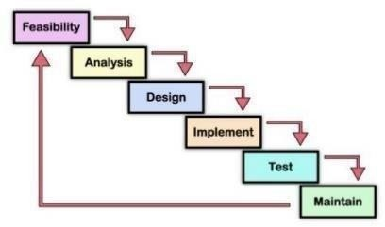

**Waterfall Model**

The Waterfall Model was the first Process Model to be introduced. It is also referred to as a **linear-sequential life cycle model**. It is very simple to understand and use. In a waterfall model, each phase must be completed before the next phase can begin and there is no overlapping in the phases.

The Waterfall model is the earliest SDLC approach that was used for software development.

The waterfall Model illustrates the software development process in a linear sequential flow. This means that any phase in the development process begins only if the previous phase is complete. In this waterfall model, the phases do not overlap.

### Waterfall Model – Design

Waterfall approach was first SDLC Model to be used widely in Software Engineering to ensure success of the project. In "The Waterfall" approach, the whole process of software development is divided into separate phases. In this Waterfall model, typically, the outcome of one phase acts as the input for the next phase sequentially.

The following illustration is a representation of the different phases of the Waterfall Model.

## Waterfall Diagram

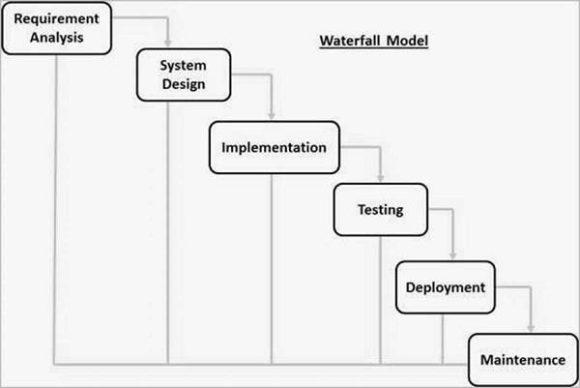

### When to use SDLC Waterfall Model?

SDLC Waterfall model is used when

* Requirements are stable and not changed frequently.
* An application is small.
* There is no requirement which is not understood or not very clear.
* The environment is stable
* The tools and technology used is stable and is not dynamic Resources are well trained and are available.

### Waterfall Model – Application

Every software developed is different and requires a suitable SDLC approach to be followed based on the internal and external factors. Some situations where the use of Waterfall model is most appropriate are –

* Requirements are very well documented, clear and fixed.
* Product definition is stable.
* Technology is understood and is not dynamic.
* There are no ambiguous requirements.
* Ample resources with required expertise are available to support the product.
* The project is short.

### Waterfall Model – Advantages

The advantages of waterfall development are that it allows for departmentalization and control. A schedule can be set with deadlines for each stage of development and a product can proceed through the development process model phases one by one.

Development moves from concept, through design, implementation, testing, installation, troubleshooting, and ends up at operation and maintenance. Each phase of development proceeds in strict order.

Some of the major advantages of the Waterfall Model are as follows –

* Simple and easy to understand and use
* Easy to manage due to the rigidity of the model. Each phase has specific deliverables and a review process.
* Phases are processed and completed one at a time.
* Works well for smaller projects where requirements are very well understood.
* Clearly defined stages.
* Well understood milestones.
* Easy to arrange tasks.
* Process and results are well documented

### Waterfall Model – Disadvantages

The disadvantage of waterfall development is that it does not allow much reflection or revision. Once an application is in the testing stage, it is very difficult to go back and change something that was not well-documented or thought upon in the concept stage.

The major disadvantages of the Waterfall Model are as follows –

* No working software is produced until late during the life cycle.
* High amounts of risk and uncertainty.
* Not a good model for complex and object-oriented projects.
* Poor model for long and ongoing projects.
* Not suitable for the projects where requirements are at a moderate to high risk of changing. So, risk and uncertainty is high with this process model.
* It is difficult to measure progress within stages.
* Cannot accommodate changing requirements.
* Adjusting scope during the life cycle can end a project.
* Integration is done as a big-bang. at the very end, which doesn't allow identifying any technological or business bottleneck or challenges early.

## DFDs (Data Flow Diagrams):

Data flow diagram is graphical representation of flow of data in an information system. It is capable of depicting incoming data flow, outgoing data flow and stored data. The DFD does not mention anything about how data flows through the system.

There is a prominent difference between DFD and Flowchart. The flowchart depicts flow of control in program modules. DFDs depict flow of data in the system at various levels. DFD does not contain any control or branch elements.

1. **Zero Level DFD**
2. **First Level DFD**
3. **Second Level DFD**

**Zero Level DFD:**

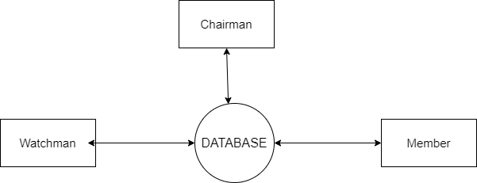

**First Level chairman DFD:**

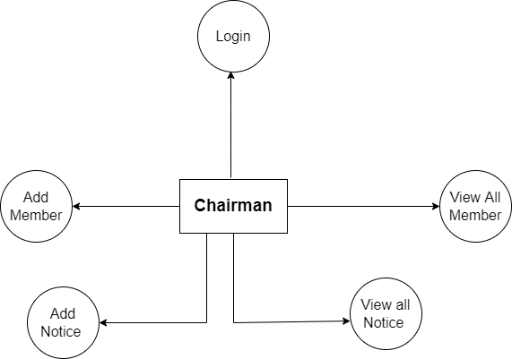

**First Level Member DFD:**

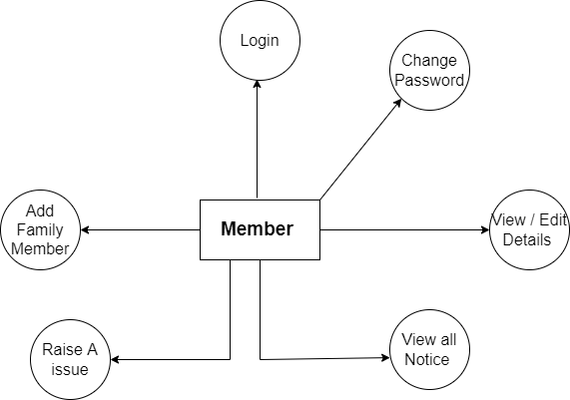

**First Level Watchman DFD:**

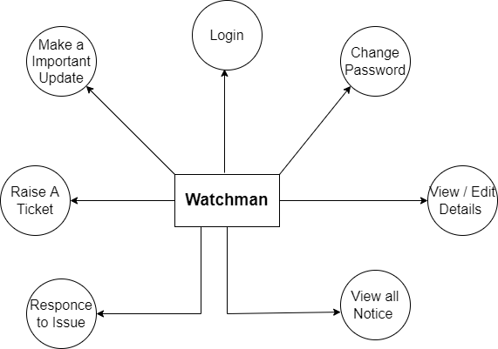

**Second Level Member DFD:**

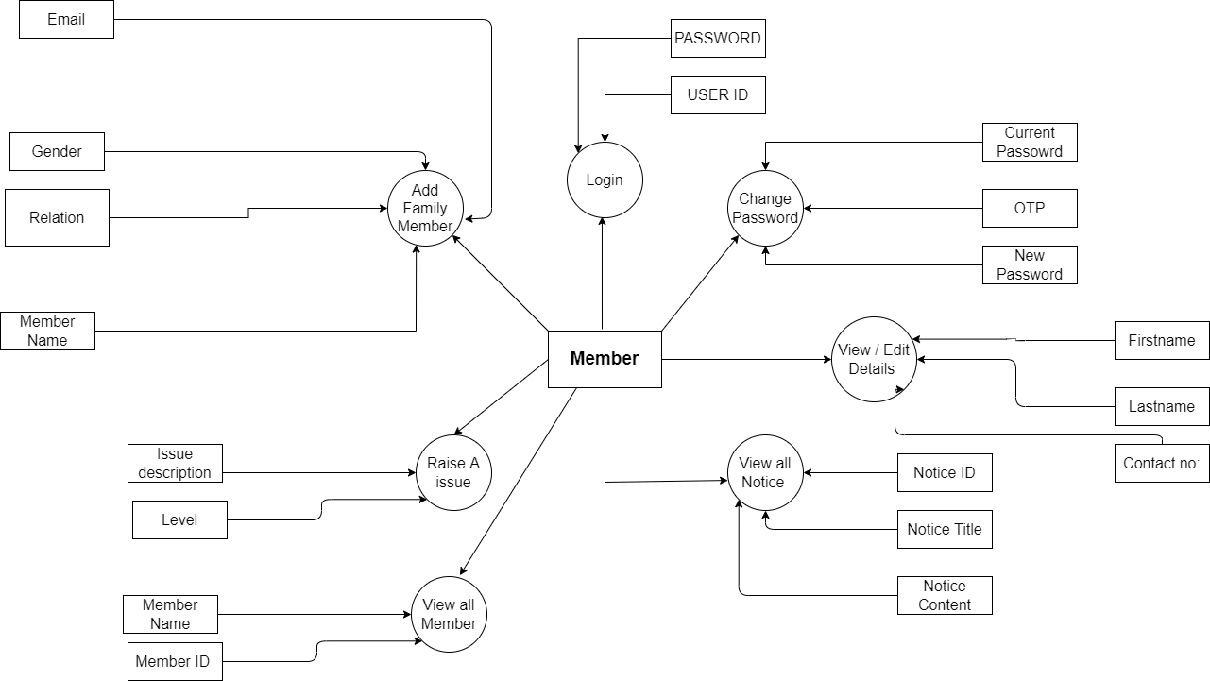

**Second Level Chairman DFD:**

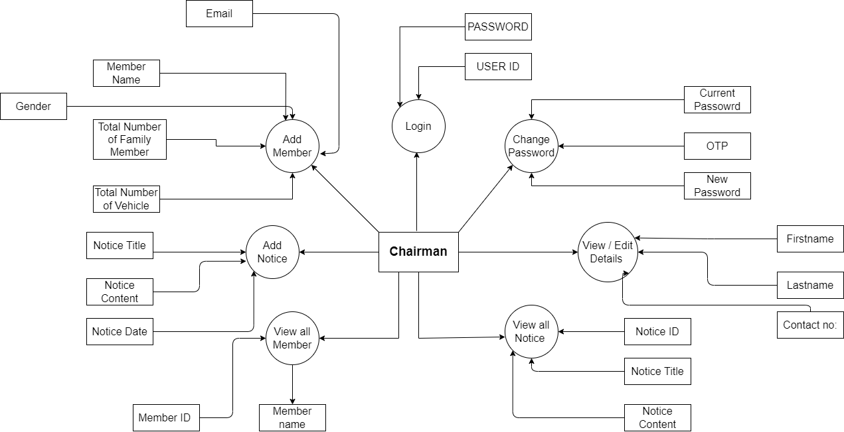

**Second Level Watchman DFD:**

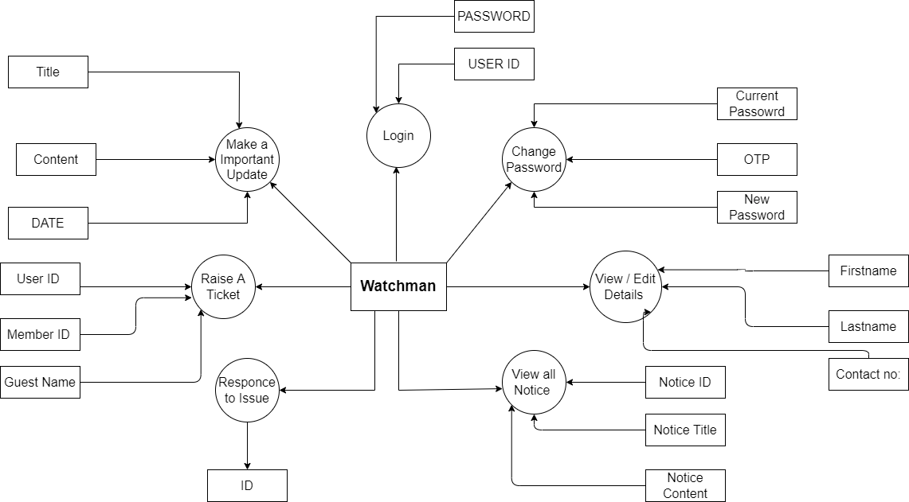

**ER-DIAGRAM**

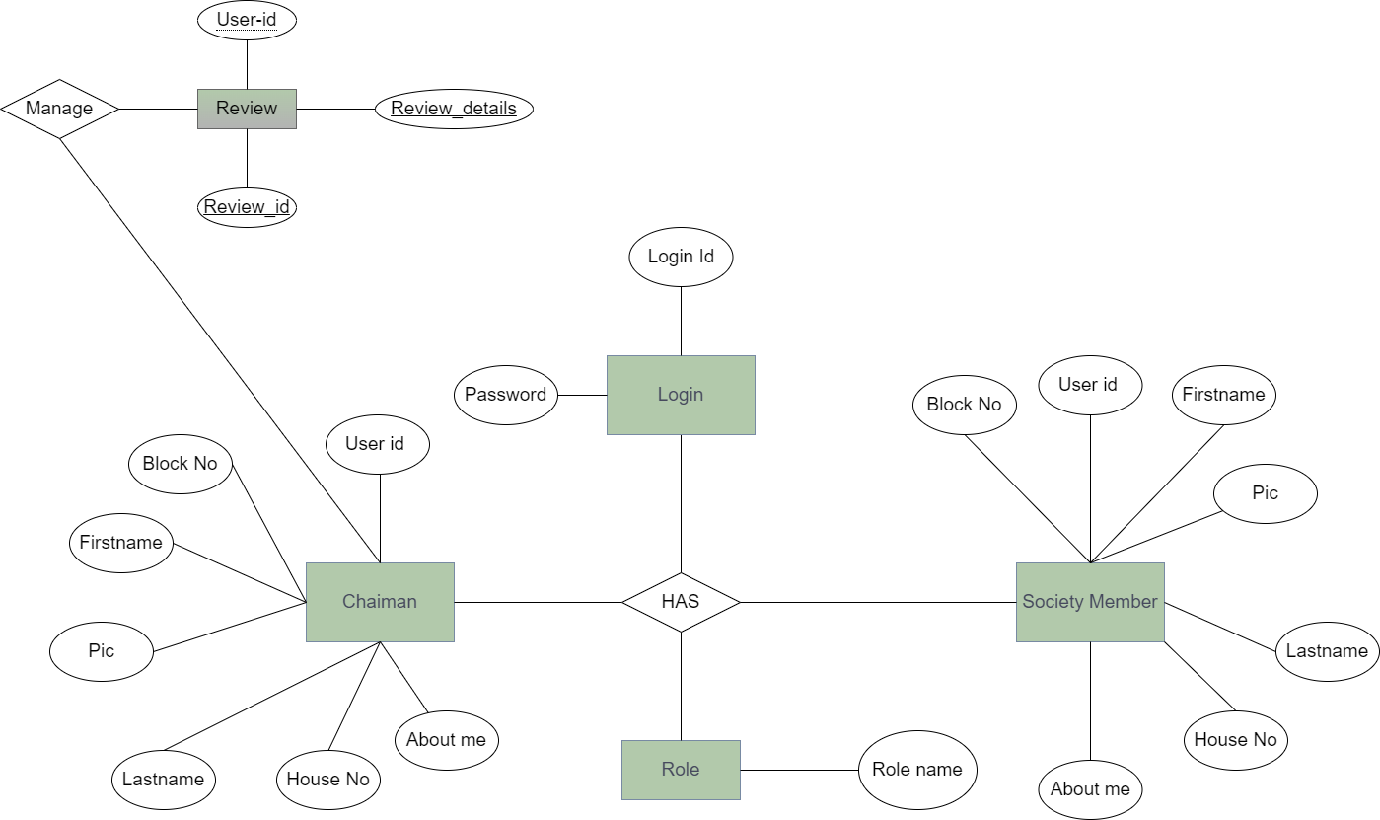

**Class Diagram**

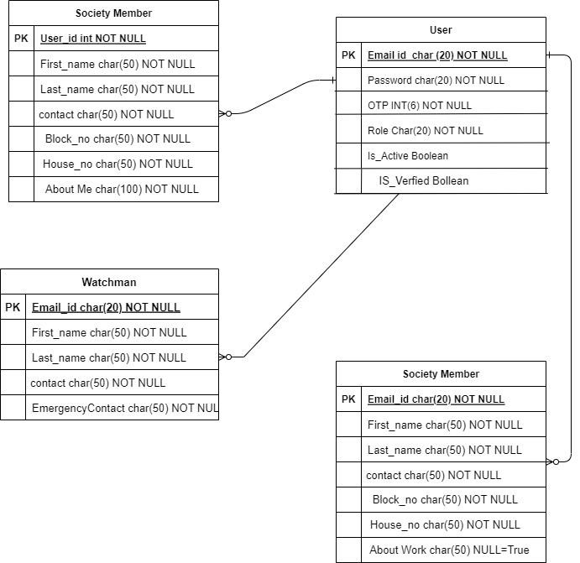

# Screenshots

## Login Page

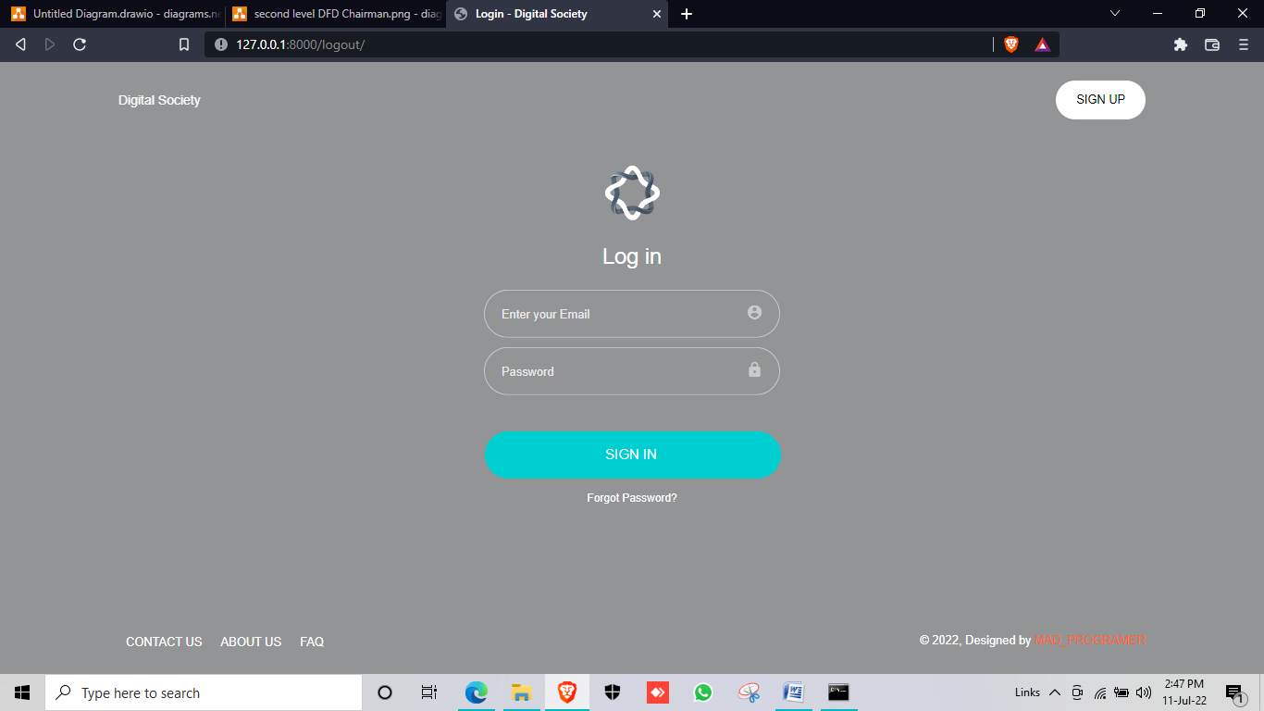

## Home Page

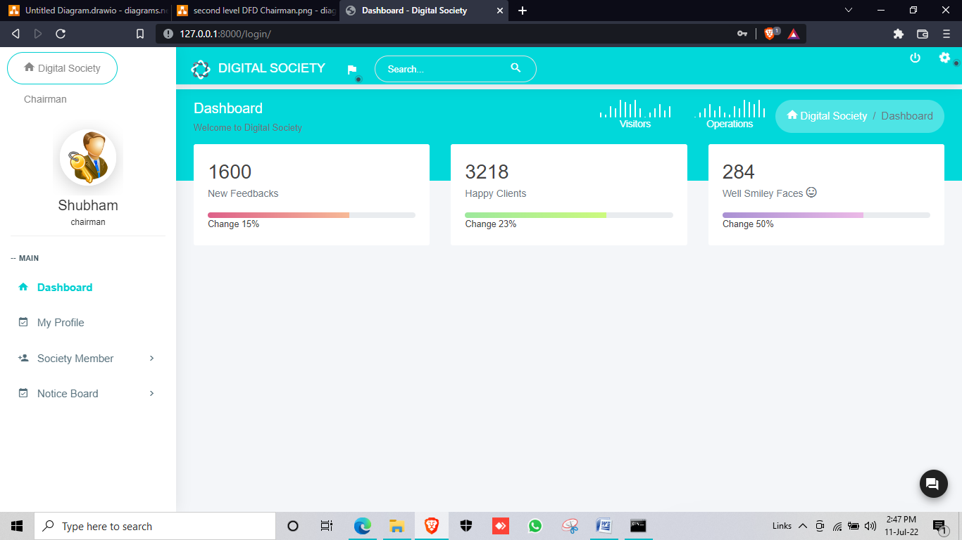

**Add Member Page**

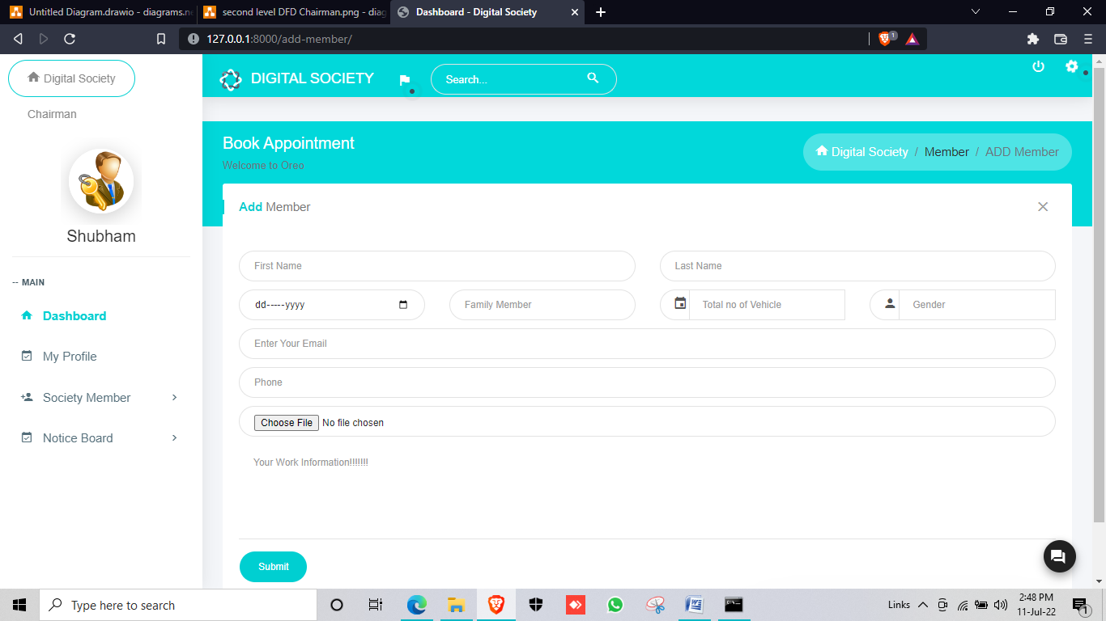

**Add Notice:**

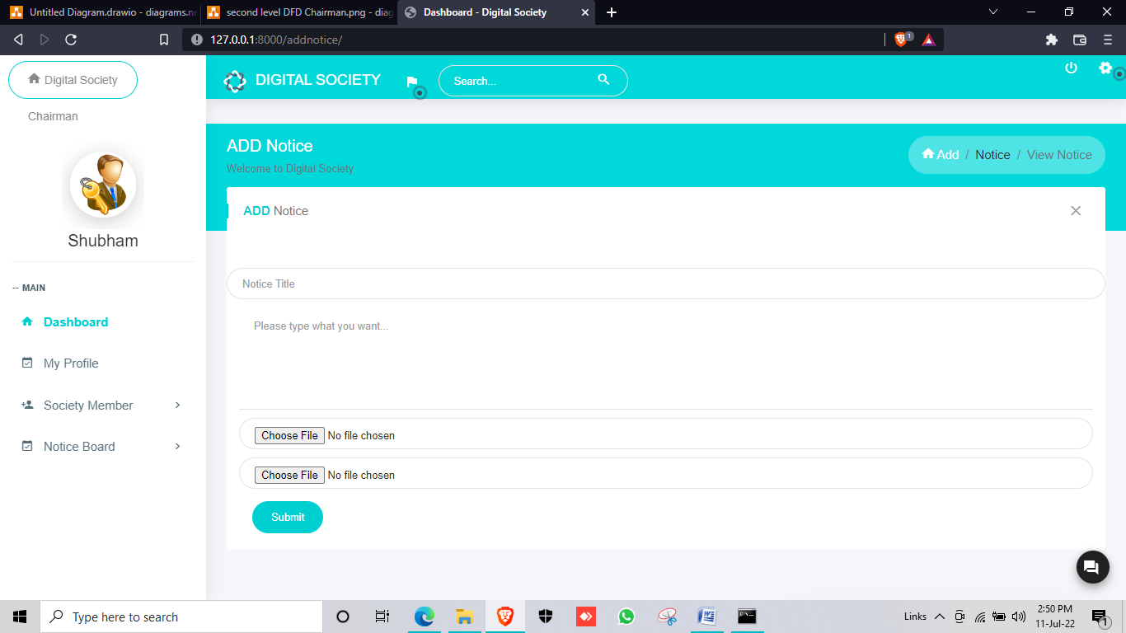

# Further Enhancement

## Further Enhancement:

* Better UI With easy Interface
* New Updates Regularly.
* Expand from one Society to Multiple
* New Security Protocol
* Notify about nearby Event with the help of GPS enable.
* Bugs will also be removed.
* Update will Get smoother
* Better performance.
* Fast Working.

# Conclusion

## Conclusion:

The Digital Society gives the New and Advance features to the Every Society to Improve their current system as well update their Security

With the Security Protocol The Society Get suggested best Security Protocol according to enter information

The chairman ,Society Member & Watchman can Brings the Change into the Society

The Society Become the more smarter and more Advance using this Idea

The digitalization is the Future so it’s the first step Towards the Digital Society